**Perth Amboy's Ahsia Torres wins state wrestling title**

PHILLIPSBURG – Ahsia Torres stays cool and knows what she’s doing.

So when the Perth Amboy senior allowed a reversal in the NJSIAA state final for the first points she surrendered all season, no problem. She quickly diagnosed the situation and used that knowledge to later score a pin to win the 107-pound title.

Torres leapt into the arms of coach Rob Morales and the celebration was on. She’s the school’s first girls state champion in program history and the first Perth Amboy state wrestling champion since Ferman Crisco won in 1992.

“I just feel like this is my ultimatum goal and I reached it,” Torres said. “I worked so hard in the offseason. … I kept my head focused. I worked on my goals and that’s what I did. I got better and achieved it.

"I just feel so special right now. I just wanted to make everyone happy and proud of me, so that’s what it felt like .and I’m just happy. So happy.”

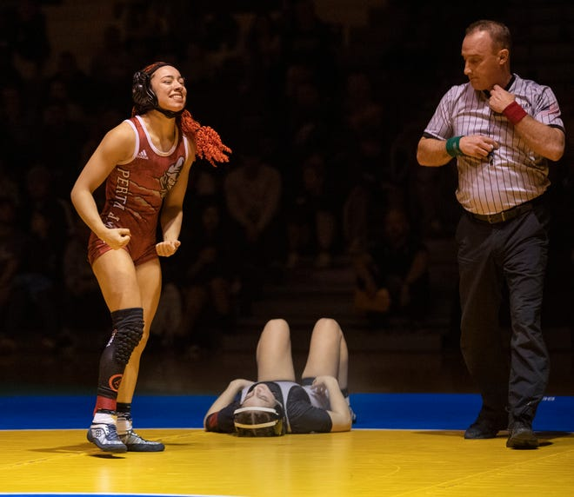

Sunday, she scored three pins at Phillipsburg High School to cap a dominant season. Torres finished 18-0 with 16 pins, a technical fall and a 14-0 win. As a sophomore, Torres placed fifth in the state at 107.

**MORE:**[Perth Amboy's Ahsia Torres enters state tournament unbeaten](https://www.mycentraljersey.com/story/sports/2022/02/19/perth-amboys-ahsia-torres-enters-state-tournament-unbeaten/6857065001/)

Last season, Perth Amboy didn’t field a team because of the administration’s safety concerns for COVID-19.

She simply kept working and willed herself into earning a gold medal. Even on a family trip to Puerto Rico, she found time to run on the beach.

“Now she can take a deep breath and be a senior now,” Morales said. “She’s been grinding probably since her last win in 2020. That’s when she took fifth place and she didn’t stop. She didn’t stop working. She was ready. She was ready for almost a year and I’m so proud of her.”

In the Sunday’s quarterfinals, Torres stopped Somerville’s Emme Hoarle in 1:38 and pinned Pennsville’s Kloi Tighe in 1:42. The final was no different against a familiar opponent.

In the North Region championship on Feb. 12, Torres pinned Zeppetelli with an arm bar in 1:25

In the state final, Torres controlled the first period and built a 7-0 lead. However, in the second period her opponent had a reversal, and it looked for a moment that Torres might be in trouble.

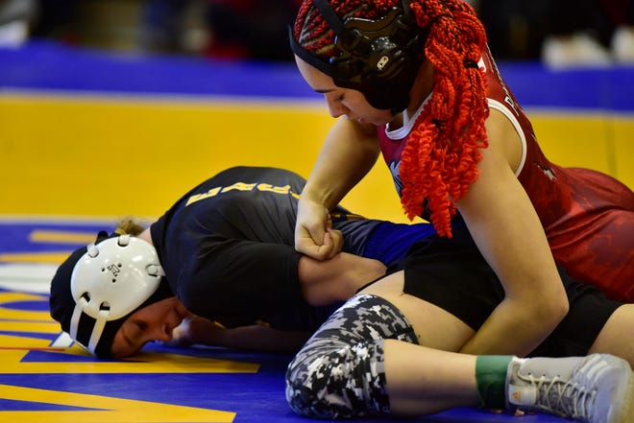

But she knew the positioning and in the third period rolled out, which led to a fall.

“I usually like to keep calm because in certain situations you don’t like to panic,” Torres said. “So I was just waiting for her to reach up on one side and then roll her. So that’s exactly what I did to her at the end and then I got the pin. I was like, ‘Yes.’”

Morales said that she has a “very high IQ in wrestling.”

“She knows what she’s doing out there,” he said. “She just waited and you could see she made the adjustment right away. … She waited. She waited. Patient and then boom, she hit the roll. She puts you on your back. She’s like a shark in water – smells blood and she’s going to pin you. That’s what she wants to do.”

Sunday, Torres sported bright red hair and a long braid. Her parents and brothers also spray painted their hair red for support.

“I try to be bold,” Torres said with a laugh. “I love doing something fun with my hair.”

On the mat, it was the same results.

“She works so hard and I’m going to miss her,” Morales said, “but it was fun watching.”

